Supplementary Figure 1. Semiquantitative RT-PCR of the indicated genes performed on RNA isolated from wild-type primary mouse osteoblasts treated with 100nM of scrambled (SCR-) siRNA or Penk1 specific siRNA (Penk1-siRNA). PCR products were resolved on 2% agarose gel. Pictures are representative of 3 experiments.

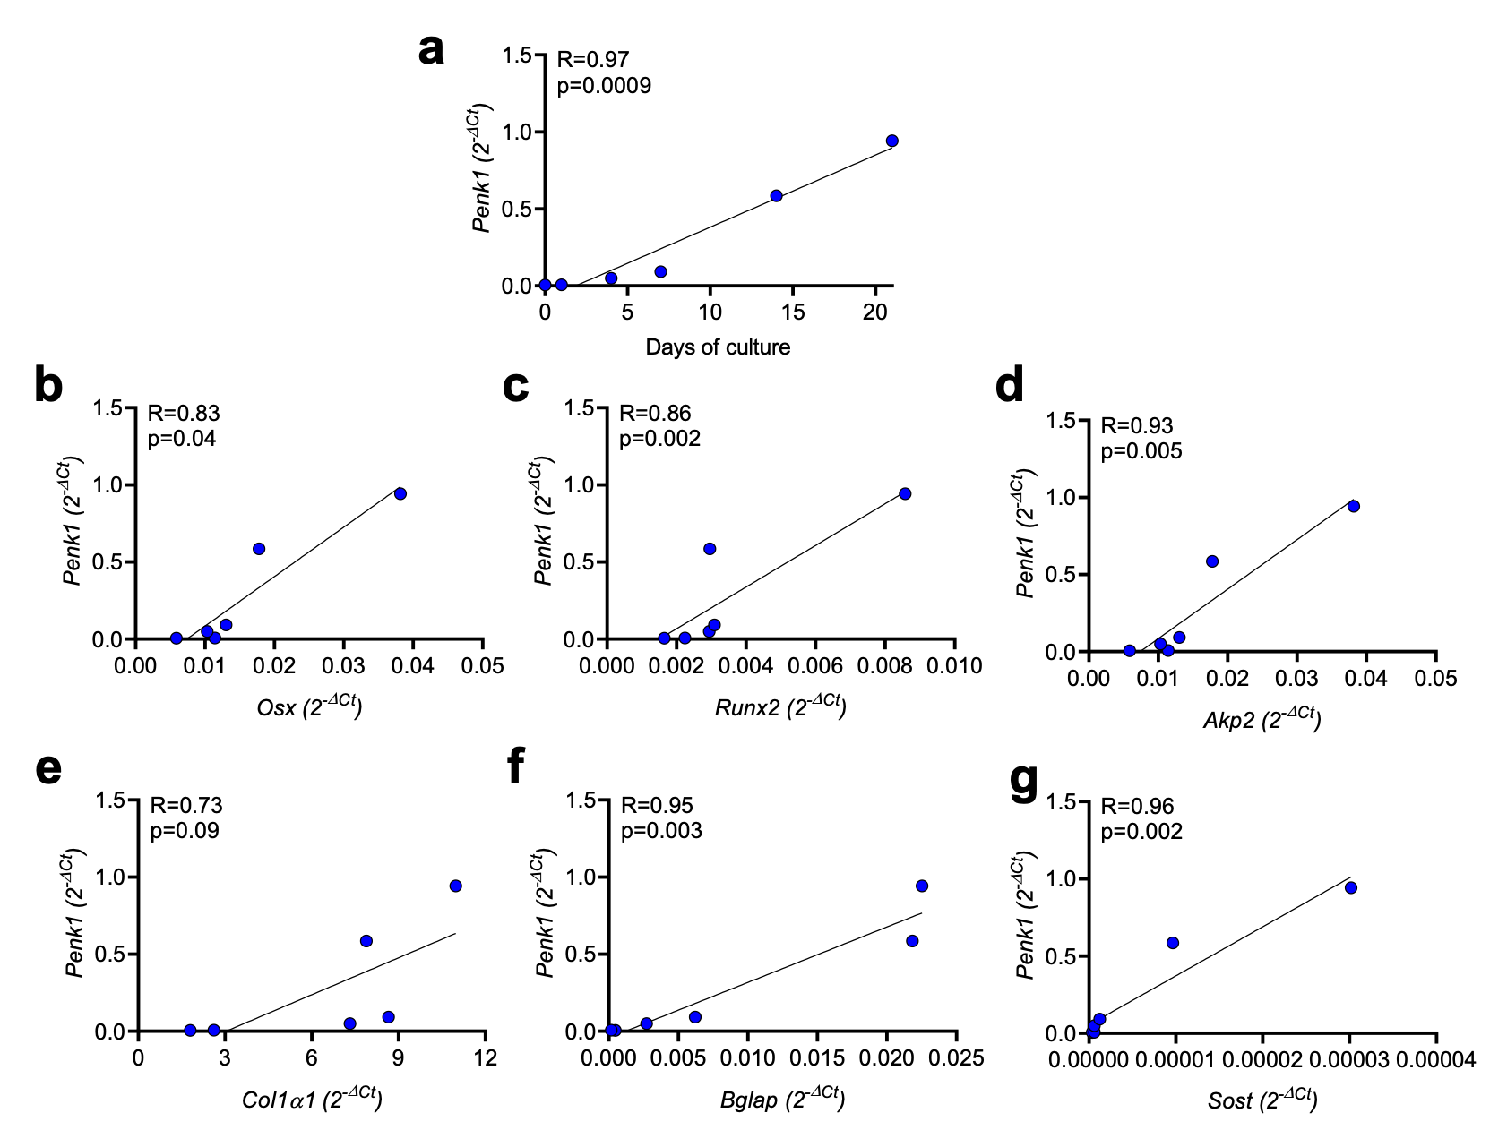
Supplementary Figure 2. Correlation analysis. Wild-type primary mouse osteoblasts were cultured in standard medium supplemented with 10 mM β-glycerophosphate and 50 µg/mL ascorbic acid (osteogenic medium). RNA was isolated at T0, T1, T4, T7, T14 and T21 culture days and the indicated genes were evaluated by real time RT-PCR. Correlation analysis was performed between Penk1 and the indicated osteoblast differentiation markers. Genes expression is reported as 2^{-ΔCt}. Pearson’s correlation analysis. R and p values are shown in the graph.

Supplementary table 1. Real time primers sequences.
Gene | Forward primer | Reverse primer
Gapdh | 5′-TGTGAGGGAGATGCTCAGT-3′ | 5′-TGTTCCTACCCCCAATGTG-3′
Penk1 | 5′-GACAGCAGCAAACAGGATGA-3′ | 5′-GTTGTCTCCCGTTCCCAGTA-3′
Akp2 | 5′-CCAGCAGGTTTCTCTCTTGG-3′ | 5′-CTGGGAGTCTCATCCTGAGC-3′
Runx2 | 5′-CCCAGCCACCTTTACCTACA-3′ | 5′-TATGGAGTGCTGCTGGTCTG-3′
Osx | 5′-TGCTTCCCAATCCTATTTGC-3′ | 5′-AGAATCCCTTTCCCTCTCCA-3′
Col1α1 | 5′-CACCCTCAAGAGCCTGAGTC-3′ | 5′-GTTCGGGCTGATGTACCAGT-3′
Bglap | 5′-TTCTGCTCACTCTGCTGACC-3′ | 5′-GGGACTGAGGCTCCAAGGT-3′
Sost | 5′-ACAAGGATGGGAGGTGACTG-3′ | 5′-ACCCCGTGTAGACTGGTGAG-3′
RankL | 5′-AGCCGAGACTACGGCAAGTA-3′ | 5′-CCACAATGTGTTGCAGTTCC-3′
Opg | 5′-AGTCCGTGAAGCAGGAGTG-3′ | 5′-CCATCTGGACATTTTTTGCAAA-3′
Il-1β | 5′-GCCCATCCTCTGTGACTCAT-3′ | 5′-AGGCCACAGGTATTTTGTCG-3′
Il-6 | 5′-GTTCTCTGGGAAATCGTGGA-3′ | 5′-GGAAATTGGGGTAGGAAGGA-3′
Wnt3a | 5′-TACCCGATCTGGTGGTCCTT-3′ | 5′-GGGCATGATCTCCACGTAGT-3′

Supplementary Table 2. Selection of the most significantly regulated genes expressed as the ratio between osteoblasts treated with Penk1-specific siRNA (siPenk1) and osteoblasts treated with scrambled siRNA (siSCR).
Gene Symbol | Gene Name | siPenk1/siSCR (fold change)
 | Up-regulated genes
Sost | Sclerostin | 33.17
Enam | Enamelin | 6.28
Tfip11 | Tuftelin interacting protein 11 | 5.66
Itga2 | Integrin alpha-2 | 4.60
Nfkb1 | Nuclear factor kappa-b, subunit 1 | 2.74
Ambn | Ameloblastin enamelmatrix protein | 2.71
Igf1r | Insulin-line growth factor 1 receptor | 2.13
Vegfb | Vascular endothelial growth factor beta | 2.03
 | Down-regulated genes
Col10a1 | Collagen 10a1 | 0.04
Egf | Epidermal growth factor | 0.05
Itga3 | Integrin alpha-3 | 0.16
Bmp2 | Bone morphogenetic protein 2 | 0.16
Csf2 | Colony-stimulating factor 2 | 0.18
Tnf | Tumor necrosis factor | 0.18
Bmp3 | Bone morphogenetic protein 3 | 0.24
Bmpr1a | Bone morphogenetic protein receptor 1a | 0.26
Col11a1 | Collagen 11a1 | 0.27

Supplementary Table 3: Bone histomorphometric variables in 3-month-old WT and Penk1^{-/-} mice
 | Males |  |  | Females
 | WT | Penk1^{-/-} | p value | WT | Penk1^{-/-} | p value
Oc.S/BS, % | 11.69 | 11.62 | 0.96 | 12.56 | 11.53 | 0.60
Oc.N/BS (mm⁻¹) | 3.52 | 3.38 | 0.74 | 4.96 | 4.96 | 0.99
Ob.S/BS, % | 9.63 | 11.47 | 0.39 | 9.22 | 8.39 | 0.55
Ob.N/BS (mm⁻¹) | 6.03 | 6.68 | 0.52 | 5.37 | 5.29 | 0.71
BFR(μm²/μm/day) | 1.11 | 1.24 | 0.54 | 1.19 | 1.17 | 0.95
MAR (μm/day) | 2.52 | 2.92 | 0.20 | 3.28 | 3.62 | 0.62

Supplementary Table 4: Bone histomorphometric variables in 12-month-old WT and Penk1^{-/-} mice
 | Males |  |  | Females
 | WT | Penk1^{-/-} | p value | WT | Penk1^{-/-} | p value
Oc.S/BS, % | 4.92 | 5.64 | 0.67 | 6.26 | 5.88 | 0.65
Oc.N/BS (mm⁻¹) | 1.87 | 2.46 | 0.36 | 1.77 | 2.27 | 0.29
Ob.S/BS, % | 5.43 | 4.792 | 0.52 | 5.09 | 4.62 | 0.34
Ob.N/BS (mm⁻¹) | 3.32 | 3.25 | 0.89 | 3.63 | 3.49 | 0.67
BFR(μm²/μm/day) | 0.45 | 0.37 | 0.53 | 0.47 | 0.39 | 0.25
MAR (μm/day) | 1.68 | 1.73 | 0.85 | 1.15 | 0.99 | 0.07

