Antonio Opromolla

AI, Big Data, and IoT for Social and Environmental Sustainability

in a Digital Transformation Course

Social, Environmental, and Economic Sustainability in Socio-Technical Systems

Social sciences are paying a particular attention to the way social and technological levels are now deeply linked. The dimension that best describes these processes is the one of socio-technical systems, an expression referring to the complex interaction between social organisations (including social institutions, interpersonal relations, and cultural processes) and technological systems (including communication technologies, infrastructures, and scientific innovations), arguing that they can significantly influence the structure and functioning of societies (Miller, 1978). This concept is present in the work of many sociologists, with different focuses. In 1990, for example, Giddens elaborated the concept of disembedding, emphasizing how technological systems can amplify the strength and speed of social change, with an impact both on individuals and on social institutions. One of the most important contributions on this topic is certainly represented by Castells. In his work (1996, 1997, 1998) he discusses the concept of network society, characterized by the central role of communication and information in social and economic organisations, going beyond geographical and temporal boundaries and enabling new forms of political and cultural participation. Moreover, in 2005 Latour developed the actor-network theory, focusing on human and non-human actors’ agency in terms of social reality construction and on their equal impact in defining cultural practices and social relations.
Although the concept of socio-technical systems has not been defined recently, it received new impetus with the evolution and ever-increasing use of digital technologies. Nowadays, Artificial Intelligence (AI), Internet of Things (IoT) and Big Data are among the most promising technologies in terms of social transformation. AI focuses on creating systems mimicking human abilities such as decision-making, learning, and problem-solving; IoT refers to networks of interconnected devices collecting and exchanging data; finally, big data involves the collection, storage, and analysis of vast datasets, which enhance decision-making processes and allow predictive insights. They differ in terms of pervasiveness (e.g.: IoT’s integration into physical spaces versus AI’s application in digital spaces), modifications (e.g.: quick possible modifications of people behaviors due to AI application versus automatic adaptations of IoT devices, also without people interaction), architectures (centralized data hubs for big data versus distributed sensor networks in IoT), and relational grammars (how these technologies interact with users and other systems), but can be considered as promising for socio-technical systems. Indeed, nowadays digital media constitute a key element of this “technical” realm and their social applications are widely evident, increasing the connection between economic, political, cultural and social activities (Manzini, 2015). On this basis, many sociologists analyse the social implications of technology, on the perspective of people - see, for example, the work of Tufekci (2017) on how digital platforms and communities shape social interactions, political movements, and spread of information through algorithmic bias and online communities dynamics - on the perspective of companies (Zuboff, 2019), and on the one of the society as a whole (Van Dijck, Poell, De Wall, 2018).
According to Abbas and Michael (2023), nowadays the research topics on socio-technical systems also focuse on design as a key component to align human elements (skills, culture, and interaction) with technical ones (tools, processes, and technology) to maximize system efficiency and effectiveness, and to adapt to external changes, ensuring resilience and sustainability. One aspect to consider is the way design can help to integrate new technologies according to a socio-technical framework. For example, Sartori and Theodorou (2022) have emphasized how a collaboration between sociology and AI studies can address biases by enhancing transparency, accountability, and understanding AI’s role in social contexts and narratives. Moreover, Aseeri and Kang (2023) focus on a socio-technical perspective on big data, which enhances decision-making (e.g. describe, predict, and prescribe specific situations) by integrating technical capabilities with organizational culture and people attitudes. Finally, Donghee (2014) investigates the complex interaction between social and technical aspects of the IoT, by highlighting the co-evolution and the human-technical interaction, describing the challenges in the design and development of the different parts of the IoT for a better experience for people. So, the new challenge for socio-technical systems consists of how these technologies impact social structures and processes. This process can be summarized under the expression of digital transformation, which refers to cultural, organizational, and social changes due to the increasingly pervasive presence of digital technologies in various areas of human life (Opromolla, 2021).
However, it is not only a matter of digital technologies. The interconnection of social and technical levels increases the complexity of systems, which makes the following features as necessary: adaptability to changes in social and technical environments; collaboration among different stakeholders; evolution, through continuous feedback and learning; interdisciplinary, permitting the collaboration among engineering, sociology, and psychology; and management of the structure, including specific practices guiding the system (IxDF, 2016b). Given the high influence of these processes on the entire society as well as on different typologies of communities, it is necessary to drive them, to achieve a positive social impact. This means simultaneously strengthening social, economic, and environmental sustainability. Social sustainability focuses on wellbeing, equity, and community engagement, supporting inclusion and cultural diversity. Environmental sustainability ensures that human activities do not have a negative impact on the environment. Finally, economic sustainability refers to the need of creating economic models which are resilient and inclusive. These three dimensions cannot be individually considered. For example, only by strengthening participation and inclusion it is possible to make environmental issues central to society and implement production systems respectful of the environment; moreover, only implementing circular economy mechanisms (for example, with waste reduction) it is possible to realize the economic sustainability; finally, only considering human needs and perspectives, it is possible to create a resilient economic system. In specific socio-technical contexts, to make an example, such as the development of smart cities, these dimensions interact dynamically: environmental sustainability is promoted by IoT-based energy-efficient infrastructures, economic sustainability is supported by cost-effective urban planning and resource optimization, and social sustainability is ensured by designing inclusive systems that address diverse community needs. In short, sustainability needs a multidisciplinary approach (de Vries et al., 2019), whose aim is to create a sustainable society (Crespi and Salvi, 2021), by developing solutions against climate change, the scarcity of resources, etc., but which needs many activities: adopting integrated solutions, restructuring education and research, developing policies (macro-actions, global perspective) as well as promoting civic engagement (micro-actions, local perspective: Bottini, 2023).
Examples of practical applications on the use of digital technologies to address sustainability challenges (in socio-technical systems) can be presented in different domains:
- IoT in smart agriculture: Klerkx and Rose (2020) discuss how Dutch farms utilize IoT devices and AI to optimize resource use and improving the quality of products, for example, some automated milking and feeding robots monitoring animal health, optimizing feeding schedules, and measuring soil moisture and nutrient levels for precision farming;
- Smart cities: Hollands (2008) discusses the project in Barcelona, where the integration of IoT sensors throughout the city allows to manage energy consumption (e.g.: smart lighting systems adjust brightness based on pedestrian activity, reducing electricity use by 30%);
- Wildlife Conservation: Chan et al. (2023) use small aerial robots tracking multiple radio-tagged wildlife species in complex terrains, addressing the challenges of traditional wildlife monitoring methods, often labor-intensive and limited in scope.
In the above mentioned examples, ethics issues concerning data privacy, surveillance, possible attacks, lack of data ownership, economic inequality can arise. Robust protocols, data collection policies, anonymised data storage processes, etc. can be adopted to mitigate risks. However, integrating social, economic, and environmental sustainability in socio-technical systems presents significant challenges. Satisfying at the same time social needs (which are diverse in terms of stakeholders and cultural backgrounds), economic dimension (which, relating to sustainability, has a different meaning than the traditional one, now more focused on long-term value creation), and environmental objectives (which usually require significant changes to existing processes) is not easy. As an example, environmentally sustainable practices may increase costs or require changes in workforce practices, impacting economic performance and social stability. Then, integrating sustainable-oriented topics in socio-technical systems can be difficult due both to cultural resistances from existing social networks and digital evolution and integration, which needs both educational activities and investigation regarding technological opportunities. Moreover, socio-technical systems need to adapt to dynamics that occur (e.g. in social behaviors or in the market); so, not only is it necessary to define from the beginning the impacts that the solutions need to reach, but also to identify tools allowing continuous monitoring. Considering all this, integrated approaches, able to capture different dimensions, to systemically think, to engage stakeholders, to foster a culture of sustainability, and to iteratively design solutions that fit with all the existing needs is necessary.

Governing Complexity in Socio-Technical Systems: the Role of Design Sociology

The processes described in the previous section are very complex and new skills are required to manage the emerging complexity. Indeed, specific approaches able to analyse and guide this complexity are necessary. In social sciences, increasing importance is represented by design sociology, an approach that applies tools and concepts of the design discipline as sociological research methods, especially with the objective of exploring people’s engagement with systems and services, better engaging with stakeholders, generating useful insights for the definition of new solutions for society and/or communities that can change cultural forms, and working towards social change (Lupton, 2018). With reference to socio-technical systems, design sociology helps sociological research at identifying insights which can increase their effectiveness and equity.
More specifically, the design thinking, as one of the methods of the so called sociology through design, is an approach structured in five main phases (IDEO.org, 2015) that aims at applying design tools and methods: to analyze human feelings and behaviors (phase of empathize), to identify problems (phase of define), to generate new ideas able to establish new relational dynamics (phase of ideate), to create a tangible prototype of the final solution (phase of prototype), to be validated with the people who will use it, also with the aim to reach a long term impact (phase of test). Humans represent the central part of this approach, since their needs and cultural backgrounds are a fundamental element to investigate, and the starting points from which to generate, test, and implement ideas that solve social problems and change cultural norms. Indeed, the design thinking methodology is part of the more general human-centered approach. According to the Interaction Design Foundation (2021), human-centered design provides solutions coherent with the needs and cultural background of people. It is based on a people-centered approach, allowing to focus on the right problems, to identify how different things are interconnected, and to create a solution able to face the predefined issues. In this sense, the objective of the human-centered design is the social innovation, an expression which indicates practices whose aim is making citizens increasingly aware of the problems affecting the community (or society) and to involve them in identifying concrete solutions that respond to their needs, thus determining economic and social growth of the community itself (Opromolla, 2020).
In these approaches, the combination of sociological (e.g. the ethnography aiming at analysing people behaviors and activities in their daily life) and design methods (e.g.: prototyping activities, aiming at creating early models to test concepts) offer the opportunity to identify the way affordances of digital and non-digital solutions at the same time are the result of specific activities and enable particular relations. Co-design, for example, especially if oriented to the implementation of digital solutions, has the objective to create products that incorporate people’s needs and desires, also in terms of the relations they intend to enable.
These activities are usually implemented during design workshops, which can be intended as interactive sessions focused on brainstorming, prototyping, and solving design problems through creative and practical exercises, using specific artifacts during the sessions, such as: maps, boards, diagrams, mockups, etc. They serve several purposes, that are: visual representation, providing a tangible representation of abstract ideas; collaboration, by providing a common reference point that all participants can interact with; idea organization, organizing thoughts and ideas systematically; documentation, since they capture the iterative process of design; testing, since they enable participants to identify potential issues and improvements before finalizing design; engagement, encouraging active participation and creative thinking from all attendees. Among them: journey maps, consisting of visual representations of people experiences with a system (IxD, 2016a); storyboards, panels that illustrate the narrative of a product or service, showing how people interact with it (Soegaard, 2024); affinity diagrams, tools for organizing amount of data or ideas into themes or groups (Dam and Teo, 2022).

Developing Competences in Educational Curricula towards Sustainability in Socio-Technical Systems

The paper intends to highlight how the development of skills related to human-centered design is necessary in curricula of higher education. More in detail, in this section, the necessary competences towards sustainability in socio-technical systems are addressed, followed by the state of the art in the scientific literature addressed to the integration of sustainability issues in university curricula (with a focus on its relation with digital transformation processes). The last part of the section is devoted to the description of a course, delivered by the author of the paper, integrating sustainability through digital transformation processes in higher education. The focus will be on the way design sociology methods and tools can improve these skills, by describing the main characteristics of the course, as well as the main results of its application.

3.1 Education towards Sustainability in Socio-Technical Systems

Competences towards sustainability in socio-technical systems encompass a range of capabilities essential for addressing contemporary challenges, considering social, economic, and environmental aspects. Before describing these competences, it is important to emphasize how this field is strictly connected to media education. According to Buckingham (2003), media education refers to teaching individuals how to critically analyze, evaluate, create, and engage with media in all its forms, equipping them with skills to navigate it complex landscape, using media responsibly, encouraging informed participation in society fostering creativity, and an understanding of media’s role in shaping culture and opinions. More in detail, in the field of sustainability in socio-technical systems, media education equips individuals to critically engage with media technologies while addressing environmental, economic, and social dimensions, fosters awareness of how they shapes perceptions of sustainability, promotes responsible use of resources, and encourages ethical practices in media creation and consumption.
Firstly, it is fundamental to provide students with interdisciplinary knowledge (Didham, Fujii, & Torkar, 2024), integrating different fields (e.g., natural sciences, informatics, social sciences, economics), where the prominence of one discipline over another can depend on the curriculum (e.g., in an informatics curriculum, technical aspects might be more emphasized). However, attention should be focused on major environmental challenges (e.g., climate change, resource scarcity, pollution, biodiversity) as well as on how to measure environmental sustainability. Furthermore, attention should be given to the key features of emerging technologies (especially the mode of operation and application fields of innovative technologies such as AI, IoT, and Big Data), including case study analyses and explorations (e.g., applied to the circular economy, sustainable transportation). Identifying benefits for different societal groups is particularly important, as it helps address disparities and adopt a more inclusive approach to sustainable development.
Beyond interdisciplinary knowledge, developing competences in systems thinking is crucial. This involves understanding the complexity of socio-technical systems, recognising the interplay between human and technological factors, and adopting a systemic approach. This means identifying feedback loops, leverage points, and potential unintended consequences within these systems (Ekselsa et al., 2023). The focus on interdisciplinary knowledge also relates to the ability to analyze and recognise the complexity of socio-technical systems. It encompasses not only the interconnection and impact of human and digital levels but also the acquisition of systemic thinking, meaning recognizing how diverse phenomena are interconnected, influencing each other, and thus identifying intervention points to improve or alter the system. Achieving this objective requires adopting a holistic perspective, which helps identify the long-term impacts of actions and decisions. Mapping and modeling tools are useful for representing both basic and complex dynamics of the system. To develop this skill, it is fundamental to analyze the characteristics of specific socio-technical systems (e.g. based on communities of members united by belonging to the same territory, by the same interests, by similar work, etc.).
Furthermore, integrating ethical considerations into sustainability education is fundamental. Students should be encouraged to critically evaluate the ethical implications of technological advancements and sustainability initiatives, understanding how decisions may affect various stakeholders and future generations (Olawumi et al., 2023). This ethical perspective should be woven throughout the curriculum, encouraging students to consider not just what is technically feasible, but what is ethically responsible. Redesigning solutions based on specific socio-technical systems according to what is ethically responsible (affecting the environmental, economic, and human dimensions) is a good exercise for students. The ethical implications of AI and Big Data in socio-technical systems require attention, since they raise issues related to privacy, algorithmic biases, and the risk of deepening inequalities. Addressing these challenges is critical to designing solutions that prioritise transparency, accountability, and fairness.
In analysing socio-technical systems, it is important to adopt not only a micro-sociological perspective (focusing on the individual) but also a macro-sociological one, which includes analysing governance structures, policies, regulations, and all stakeholders influencing socio-technical systems (Kohler et al., 2019). This aspect underscores the importance of interdisciplinary collaboration among stakeholders from various sectors (such as businesses, governments, and NGOs), considering them not only as subjects of analysis but also as active participants in designing solutions for socio-technical systems. Developing a global perspective is also important in sustainability education. This involves understanding and addressing sustainability issues on a global scale, recognizing the interconnectedness of local actions and global impacts (Žalėnienė, Pereira, 2021). Students should be encouraged to consider how sustainability practices can vary in different cultural, economic, and environmental contexts, promoting solutions that are globally informed yet locally relevant.
Hence, collaboration and stakeholder engagement are fundamental skills to teach, fostering shared understanding and commitment to sustainability goals. Participatory approaches, involving stakeholders in decision-making processes, such as participatory planning and co-design, are important (Wibeck, Eliasson, and Neset, 2022). Communication skills are, consequently, vital to facilitate fruitful collaboration among different stakeholders, both during participatory processes and to ensure positive relationships in socio-technical systems.
Participatory processes, as well as the recognition of the complexity of socio-technical systems are also connected to another crucial skill: change management. This involves identifying shortcomings in a given system and taking initiatives to change processes, services, etc., while pinpointing the necessary organisational and social changes to achieve predefined outcomes and long-term impacts. Skills in planning, executing, and evaluating sustainability projects are essential for achieving tangible outcomes and fostering long-term change.
Additionally, fostering innovation and entrepreneurial thinking is vital. Students should be encouraged to explore innovative solutions and entrepreneurial opportunities within the realm of sustainability. This can be facilitated through incubator programs, innovation labs, and collaborations with industry partners, enabling students to translate their ideas into viable, impactful ventures (Suguna, et al., 2024).
An analytical approach, focused on thorough context analysis and based on collecting and interpreting data and evidence, should also be taught. This approach provides insights essential for the system change management process, allowing the identification of problems by recognising the interconnection of root causes determining a specific situation. This should be applied both at the initial phase (to map the as-is situation) and after implementing major changes (to evaluate impacts and monitor progress). Among the most important tools for analyzing sustainability challenges are SWOT analysis, root cause analysis, and scenario planning. Finally, students need to be encouraged to think creatively to develop innovative solutions to sustainability problems. Engaging them in real-world interdisciplinary projects, case studies, and problem-based learning to solve real-world sustainability issues is crucial. This can be further enhanced through exposure to hands-on experiences, such as fieldwork, internships, and collaborative projects with external organizations, providing practical insights and real-world applications of their learning (Kricsfalusy, George, C., & Reed, 2016).
These competences prepare students to navigate and address many challenges, e.g.: creating a sustainable future, making them valuable contributors across various sectors. They prepare higher education students to become informed, proactive agents of change capable of contributing meaningfully to sustainability transitions in diverse professional fields, ensuring a sustainable future for society.

3.2 Academic Perspective towards Education on Sustainability in Socio-Technical Systems

Sustainability-related issues are becoming increasingly important from primary school, up to university. In this section the author focuses on the recent academic contributions addressed to the ways sustainability issues, especially associated and driven by digital transformation processes, are transmitted in university courses. This topic is more and more present in the academic literature (Abad-Segura et al., 2020). University students are a target increasingly affected by these issues, and this implies the need for providing supporting materials, methods, and best practices to teaching staff (Leal Filho, 2018).
Designing a curriculum on sustainability in higher education represents an important topic in the academic discussion. Poon (2017), for example, has investigated the integration level of sustainability issues in the curriculum of the Deakin University in Australia, demonstrating how it was still low, but oriented to a problem-based approach, reinforced with concrete projects. According to Ruesch Schweizer, Di Giulio, and Burkhardt-Holm (2019) the scientific support in the activity of sustainability design curriculum is important. It consists in engaging stakeholders to ensure willingness to change, addressing institutional constraints, promoting professional development, leveraging existing experiences, incorporating diverse sustainable insights, and facilitating interdisciplinary consensus. Some contributions focus on the importance of considering sustainability issues as a topic not to teach itself but connected to traditional ones. Cardiff, Polczynska, and Brown (2024), for example, focus on the way sustainable issues can be integrated in foreign language education. However, most of academic contributions focus on the integration of sustainability across different disciplines, even if this is not always easy (Argento et al., 2020).
In terms of curriculum contents, Vitting-Seerup, and Achiam (2023) have developed a science communication course aimed at incorporating sustainability principles. The course evolved from educating about sustainability (focusing on awareness), to educating for sustainability (encouraging interdisciplinary problem-solving), and finally to education as sustainability (promoting epistemic change and mutual understanding). In their study, incorporating arts-based approaches and interdisciplinary exchanges proved effective and promotes inclusive communication models. In general terms, according to Fuertes-Camacho, M.T. et al. (2019) elaborating competencies for sustainable development enables an integrated approach allowing to promote the project method in multidisciplinary teams. Indeed, for some authors, sustainability is embedded into generic academic competences (Pietikäinen et al., 2024), whereas other studies focus the attention on specific disciplines. For example, some authors have emphasised that sustainability is a topic more and more present in the “technological” university curricula, e.g. digital media design (Kao, Chen, Lo, 2023) and engineering (Nakad, Gardelle, Abboud, 2024), oriented not only to the design and implementation of sustainable products and artifacts, but also as a way of thinking interdisciplinary and of developing transformative competencies. The latter is also addressed by Disterheft (2024), who argues that sustainability in higher education contributes not only to develop care-based approaches, but also to leverage system-thinking perspectives and transformative learning approaches. Shephard (2020, 2) argues that sustainability also contributes to the development of critical thinking.
More generally, according to Shenkoia and Kim (2023), digital transformation processes and sustainability in education are more and more connected. Indeed, the increasing application of technologies in education processes, and the digital transformation as curriculum topic is also leading to study programs sustaining the fundamental sustainability principles in all life areas. This is also addressed by Veckalne and Tambovceva (2022), who state that digital transformation in education is crucial to promote sustainable development, since it enhances access to educational materials, and because blended learning models reduce the environmental footprint, but also because digital tools facilitate the integration of education for sustainability into curricula, fostering critical thinking and problem-solving skills. This opinion is also supported by other studies (e.g.: Leal Filho et al., 2023).
In this regard, the application of social innovation initiatives is important too (Melles, 2022). The work of Unceta, Guerra and Barandiaran (2021), for instance, emphasizes how higher education institutions support strategies strengthening participation and cooperation with local communities, where sustainability practices play a central role. This is exactly the topic of the work Dryjanska, Kostalova, and Vidović (2022), who discuss some higher education practices of two Countries and sectors (Czech Republic and Croatia), engaging students in practical activities consisting of participation in community projects, increasing civic engagement and responsibility.
In the academic literature, the research on how to build sustainability competencies through digital transformation (both to students and teachers) is also associated with the research on how to create smart and sustainable campuses through the application of digital technologies (Trevisan et al., 2024; Rotondo and Giovanelli, 2024). This point is very important in a specific part of the academic literature, which intends the role of the higher education institutes as crucial to implementing sustainability on a systemic level (Deneckere et al., 2024), both improving the university organization performance and by evidencing the central role of university in the society (Pischedda et al., 2024; Shephard, 2020, 1-3). For this purpose, the study of Abo-Khalil (2024) focuses on how sustainability is present in higher education, starting with an exploration of various campus sustainability assessment tools. It states that a successful integration and collaboration between educational stakeholders, industry partners, public sector, and civil society are crucial for fostering collective action and effective solutions to sustainability challenges.
Evaluation of the curriculum is also discussed in the academic literature. The study of Delaney and Liu (2023) is addressed to a design course and emphasizes how, even if sustainability issues are important in that discipline, in the United Kingdom 80% of the courses were considered as “weak” or “very weak. For this reason, the operationalisation of learning outcomes related to sustainability into higher education assessment tools is necessary (Stough et al., 2024; Ceulemans and Boitier, 2024), especially by defining common objectives among different universities (Agrawal and Parvez, 2024).
In summary, integrating sustainability into university curricula amid digital transformation involves a multidisciplinary approach, engaging stakeholders, and leveraging digital tools to promote sustainable development, at the same time fostering critical thinking, and addressing societal challenges.

3.3 A Course in Higher Education on Digital Transformation for Sustainability

In this section an existing course for higher education students linking sustainability issues with socio-technical systems is described. Its aim is to explore how digital technologies (especially AI, Big Data, and IoT) can have a positive impact on social, environmental, and economic sustainability issues.
More in detail, this course consists of two phases: a delivery teaching phase and an interactive teaching phase. During the first phase three main topics are included:
- social assumptions and implications of digital transformation, focusing on the way socio-technical systems impact in various societal domains (e.g.: healthcare, learning, work, mobility, information, public sector, etc.);
- technological opportunities for digital transformation, emphasizing the basic characteristics, operating modes, and areas of application of IoT, AI, and Big data, as well as focusing on the role of human-centered design in digital transformation;
- economic framework of digital transformation, discussing the trends of open innovation, start up, public-private collaboration, etc.
During the second phase, students are asked to choose one of the targets established by the Sustainable Development Goals, set by the United Nations, and to identify how AI, Big Data, and IoT can be at the basis of an interactive solution driving towards the achievement of the chosen goal. To do that, students are asked to follow a framework consisting of five steps, using tools proper of the design sociology approach:
- students build a deep understanding of the people affected by the chosen goal, ensuring that the solution is designed with real users in mind, prioritizing their experiences and addressing their pain points. To do that they drafted the user persona(s), fictional characters created from people research (collected through qualitative research conducted through focus groups and interviews) to represent people behaviors, needs, goals, and pain points, guiding design (Figure 1);
- students analyse the broader ecosystem, identifying all relevant actors, their relationships, and roles within the chosen field, providing insights into the dynamics, potential opportunities, and barriers that may influence the proposed solution. To do that they drafted the stakeholder map, a visual representation of people and actors involved in a specific field in a given context (Figure 2);
- students design an interactive concept solution that uses AI, Big Data, and/or IoT, that is to say identifying the characteristics of an interactive solution following people-centered and responsive environments;
- students refine the concept, mapping out how users might interact with the solution over time, identifying key touchpoints and optimizing the user experience for engagement, efficiency, and impact. They drafted the user journey map, a tool visually depicting the people’s interactions with the interactive solution (Figure 3);
- defining the long-term impacts of the identified solution, as well as the outcomes, focusing on evaluating the solution’s ability to deliver meaningful and measurable results.
The course has been delivered to 10 higher education students of an Interaction Design curriculum (the precise name of the module is digital transformation). Students come from different socio-cultural contexts (Italian, French, and Chinese) and have different backgrounds (communication, fashion design, urban landscape design, and marketing).
As a result, many different concepts have been defined:
- an interactive app enabling users to capture photos and geolocate marine litter. This data helps predict litter drift, optimizing marine clean-up operations. It also supports scientific research and clean-up strategies through crowd-sourced data, fostering a collaborative approach to environmental conservation;
- an app that promotes sustainability by integrating UI customization, real-time ecological driving tips, and energy consumption monitoring. It optimizes routes using real-time data, provides environmental impact reports, and enhances people awareness and eco-friendly driving habits;
- a platform that enables young people (along with their families, healthcare professionals, and communities) to access a comprehensive, AI-powered platform for the prevention, treatment, and support in their journey to achieve and maintain recovery from substance use disorders, fostering improved physical and mental health, restored relationships, academic and career success, and overall well-being;
- a holistic platform offering real-time tracking of hormonal changes, sustainable mental health resources, and eco-friendly lifestyle tips. It integrates social support, professional consultations, and environmental mindfulness to alleviate postpartum emotional issues, promoting well-being and sustainable living;
- an AI-based platform predicting disasters, managing resources, and aiding navigation, analyzing environmental data, at the same time raising awareness through educational tools. This integration aids authorities in real-time responses and sustainable practices;
- an ecosystem and biodiversity conservation platform allowing environmentalist to collectively record relevant information and data regarding mountain ecosystems and its biodiversity;
- an urban information real-time monitoring platform allowing city emergency management agencies, city planners, and architects to get real time environmental information during a rescue and simulate the impact of natural disasters on cities to enhance resilience of cities to natural disasters.

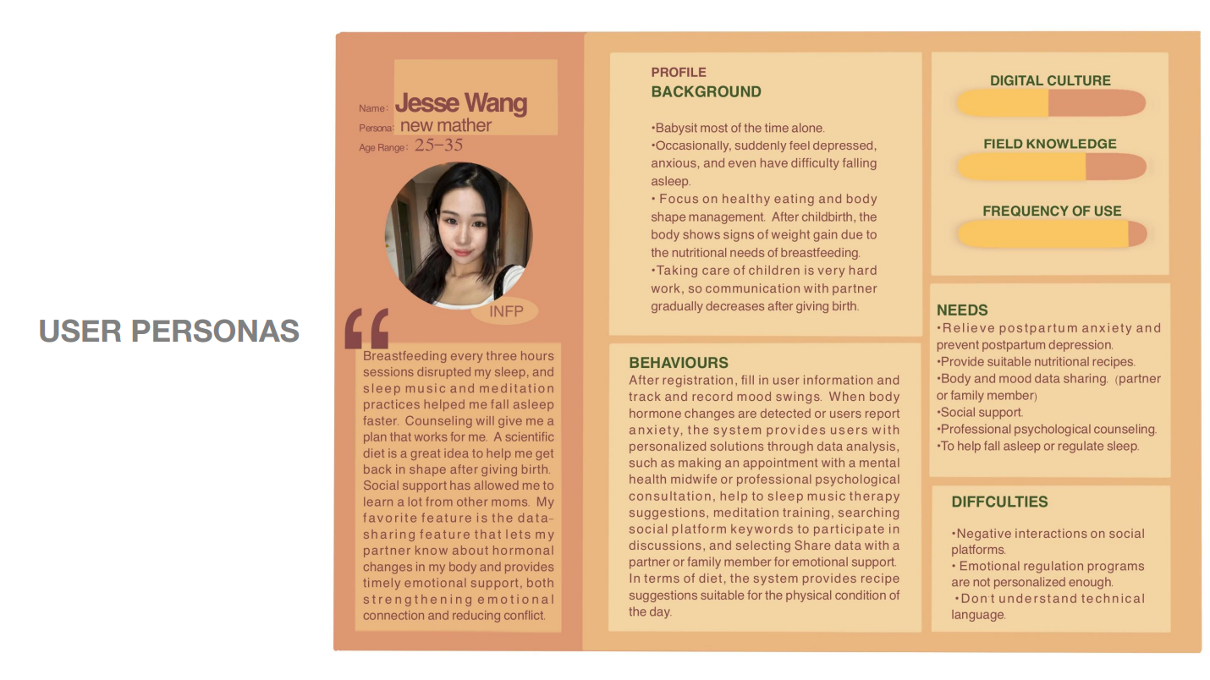
Fig. 1 - Student’s work.User persona.

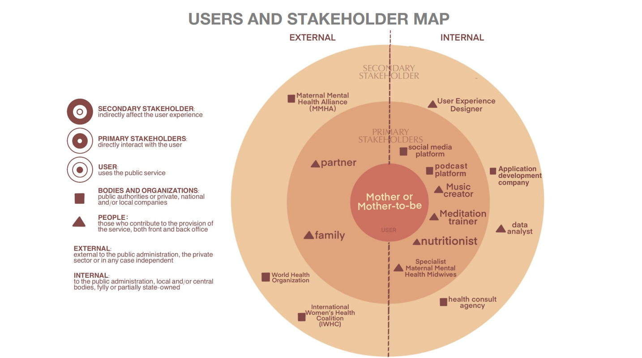
Fig. 2 - Student’s work. Stakeholder map.

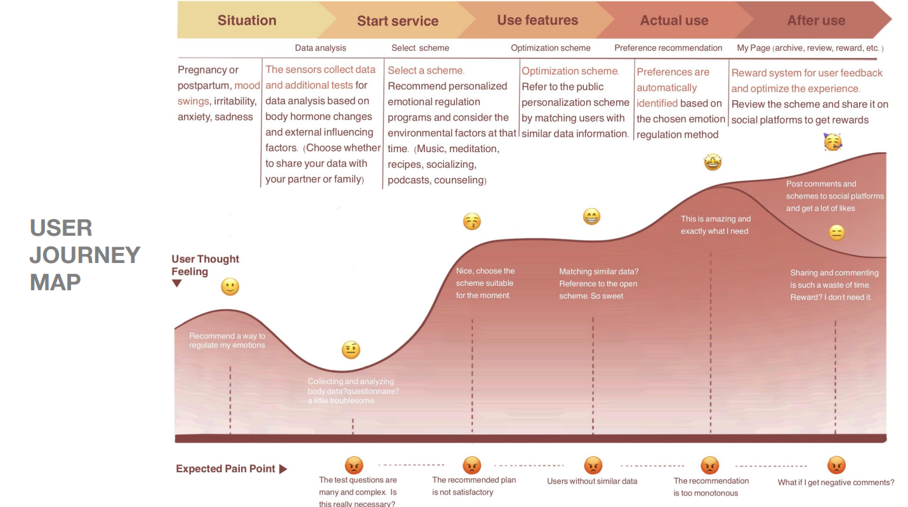
Fig. 3 - Student’s work. User journey map.

Students’ learning outcomes have been assessed through: 1. a final test with multiple choice and open questions on sustainability, socio-technical systems, and digital technologies; 2. pre- and post-course surveys, including quantitative measures (Likert-scale responses) to evaluate changes in their perception of preparedness in these topics; 3. engagement and self-reflection on their elaborated projects during public speeches. In addition, also the quality of the projects has been evaluated considering the following criteria: feasibility both related to technical aspects and to people engagement, innovation potential in terms of creativity in addressing sustainability challenges and efficacy of the solution, alignment to SDGs and related targets. The observed outcomes are satisfying in terms of students’ knowledge growth (e.g.: an average of 60% of improvement in post-course compared to pre has been observed), projects success rate (80% of the project have been evaluated as highly feasible), and implementation potential (30% of the project are evaluated as possibly developable).

Conclusions: Potential and Limits of the Study

This paper underlines the necessity of a holistic approach to integrate digital technologies for social, environmental, and economic sustainability objectives. The interconnection between social organizations and technological advancements requires new methodologies and competences to address contemporary sustainability challenges effectively. The contribution highlights the critical role of design sociology in doing that, as well as the need to enhance sociological design skills of course during specific courses. Indeed, by equipping students with the necessary competences and applying innovative design methodologies, it is possible to drive them to think about solutions able to achieve a sustainable and equitable society. In doing that, design sociology can be intended as a method aiming at social transformation and innovation.
The case study described in section 3.3 recorded positive results. As demonstrated, all the solutions devised by the students are not only in line with the requirements of the assignment, but also feasible. The projects represent only possible examples, showcasing a variety of application areas, levels of impact across different dimensions of sustainability, roles of various technologies, and, consequently, possible innovation within socio-technical systems. At present, they are merely conceptual frameworks that have been developed but have not been pursued further. This emphasizes their potential rather than their realisation, serving as starting points for exploration and discussion rather than finalized or implemented solutions.
The proposal here is not to use the described method as it is, but to consider it as one of the possible applications of the methodological approach of design sociology. This method, in fact, is flexible enough to be applied and personalized based on various variables. First of all, the level of knowledge of technologies. Design sociology does not require the participation of technical experts, but rather of people who, starting from a basic understanding of the main functionalities and application areas of the technology, are capable of envisioning the most suitable scenarios, giving to the different dimensions the same importance. Indeed, design sociology actively involves people, asking them “human” skills rather than technical ones. Then, the type of discipline subject of study. The design sociology approach can be applied not only to social science curricula, but also to more technical ones: it needs to be intended as a thinking process, aiming to address complex global and local challenges placing people and communities problems at the center. Moreover, the level of integration in university curriculum. The described approach is suitable both as an integration in university curricula and as a student engagement method in activities separated from the ones proper of their curricula: it is useful to have a deep understanding of society, considering the perspectives of different stakeholders. Finally, the concrete application of the designed solutions: it can be used both as an exercise and as a method leading to solutions that are progressively refined to be effectively implemented.
The author recognises some limits of the study. The first one is represented by the small student sample; during the second administration of the course, it is planned to involve a larger number of students. The second is represented by the scalability of the course: an additional reflection is required regarding the consideration of additional elements useful to adapt the course and the concept ideas to different socio-cultural contexts, as well as the implementation of practical collaborations with key stakeholders (to design solutions for real needs), and possible additional contents making the course even more relevant. Thirdly, the limitation of the study also may concern the method of the design sociology; indeed, even if design sociology can be considered an “umbrella” approach, encompassing multiple approaches, additional tools as well as similar methodologies (such as systems thinking, actor-network theory, user-centered design, ethnographic design, etc.) need to be explored. Finally, the importance to ethical impacts of the created projects can be better evaluated, especially in the phase of impacts definition.
Moreover, future research will focus on evaluating the long-term impacts of integrating design sociology into university curricula in terms of the ability of students to address sustainability challenges. This will be implemented by measuring the way the course impacts on the future student careers (in terms of work fields and methodological approaches). Another important element to investigate relates to the exploration of interplay between local socio-cultural contexts and global sustainability objectives, as this could reveal valuable insights into the adaptability and efficacy of such methodologies.

References
Abad-Segura, E., González-Zamar, M.-D., Infante-Moro, J.C., Ruipérez García, G. (2020), Sustainable Management of Digital Transformation in Higher Education: Global Research Trends. Sustainability 12, 2107. https://doi.org/10.3390/su12052107
Abbas, R. & Michael, K. (2023) Socio-Technical Theory: A review. In S. Papagiannidis (Ed), TheoryHub Book
Abo-Khalil A.G. (2024), Integrating sustainability into higher education challenges and opportunities for universities worldwide, Heliyon, 9(10), https://doi.org/10.1016/j.heliyon.2024.e29946
Agrawal, A., Parvez, N. (2024). Assessment Frameworks for Promoting Sustainable Development in Educational Institutions. In: Rotondo, F., Giovanelli, L., Lozano, R. (eds) Sustainability in Higher Education. Strategies for Sustainability. Springer, Cham. https://doi.org/10.1007/978-3-031-54026-4_11
Argento, D., Einarson, D., Mårtensson, L., Persson, C., Wendin, K., Westergren, A. (2020,. Integrating sustainability in higher education: a Swedish case, International Journal of Sustainability in Higher Education, 10.1108/IJSHE-10-2019-0292
Aseeri, M., Kang, K. Organisational culture and big data socio-technical systems on strategic decision making: Case of Saudi Arabian higher education. In. Educ Inf Technol 28, 8999–9024 (2023). https://doi.org/10.1007/s10639-022-11500-y
Bottini, L. (2023). The Future of Smart Cities and the Role of Neighborhoods in Influencing Sustainable Behaviors: a General Overview. Fuori Luogo Journal of Sociology of Territory, Tourism, Technology, 17(4), 89-98. https://doi.org/10.6093/2723-9608/9840
Buckingham, D. (2003). Media Education: Literacy, Learning and Contemporary Culture. Polity Press.
Cardiff, P., Polczynska, M. and Brown, T. (2024), Higher education curriculum design for sustainable development: towards a transformative approach, International Journal of Sustainability in Higher Education, 5 (25), 1009-1023. https://doi.org/10.1108/IJSHE-06-2023-0255
Castells M. (1996), The Rise of the Network Society, The Information Age: Economy, Society and Culture, Vol. I, Oxford, Blackwell
Castells M. (1997), The Power of Identity, The Information Age: Economy, Society and Culture, Vol. II, Oxford, Blackwell
Castells M. (1998), End of Millennium, The Information Age: Economy, Society and Culture, Vol. III, Oxford, Blackwell
Ceulemans, K., Boitier, M. (2024). On the Sense and Nonsense of Assessing Sustainability in Course Content: Lessons Learned from a French Business School. In: Rotondo, F., Giovanelli, L., Lozano, R. (eds) Sustainability in Higher Education. Strategies for Sustainability. Springer, Cham. https://doi.org/10.1007/978-3-031-54026-4_15
Chen, F. et al. (2023). ConservationBots: Autonomous Aerial Robot for Fast Robust Wildlife Tracking in Complex Terrains, Journal of Field Robotics, https://doi.org/10.1002/rob.22270
Crespi, I., & Salvi, A. (2021), Sustainable Development and Tourism: the Case of Lanzarote Island in the Light of the 2030 Agenda. Fuori Luogo Journal of Sociology of Territory, Tourism, Technology, 9(1), 111 - 128. https://doi.org/10.6093/2723-9608/7994
Dam, R. F. and Teo, Y. S. (2022), Affinity Diagrams: How to Cluster Your Ideas and Reveal Insights, Interaction Design Foundation - IxDF. https://www.interaction-design.org/literature/article/affinity-diagrams-learn-how-to-cluster-and-bundle-ideas-and-facts
de Vries B.J.M., Barton A.C., Cairns J., van der Leeuw S.E. (2019), Sustainability Science: A Multidisciplinary Approach, Cambridge University Press
Delaney, E. and Liu, W. (2023), Postgraduate design education and sustainability—An investigation into the current state of higher education and the challenges of educating for sustainability, Front. Sustain. 4:1148685. doi: 10.3389/frsus.2023.1148685
Deneckere, K., Henssen, B., Crois, E. (2024). Driving the Systemic Transformation of Higher Education Institutions Towards Sustainability: The Case of Education for Sustainability Hub. In: Rotondo, F., Giovanelli, L., Lozano, R. (eds) Sustainability in Higher Education. Strategies for Sustainability. Springer, Cham. https://doi.org/10.1007/978-3-031-54026-4_4
Didham, R. J., Fujii, H., & Torkar, G. (2024), Exploring Interdisciplinary Approaches to Education for Sustainable Development, Nordic Journal of Comparative and International Education (NJCIE), 8(2). https://doi.org/10.7577/njcie.5877
Disterheft, A. (2024). Nurturing a Caring University: Exploring Inner and Outer Sustainability for Transformative Change in Higher Education. In: Rotondo, F., Giovanelli, L., Lozano, R. (eds) Sustainability in Higher Education. Strategies for Sustainability. Springer, Cham. https://doi.org/10.1007/978-3-031-54026-4_2
Donghee, S. (2014), A socio-technical framework for Internet-of-Things design: A human-centered design for the Internet of Things. In: Telematics and Informatics, 31 (4), 519-531. https://doi.org/10.1016/j.tele.2014.02.003
Dryjanska, L., Kostalova, J., Vidović, D. (2022). Higher Education Practices for Social Innovation and Sustainable Development. In: Păunescu, C., Lepik, KL., Spencer, N. (eds) Social Innovation in Higher Education. Innovation, Technology, and Knowledge Management. Springer, Cham. https://doi.org/10.1007/978-3-030-84044-0_6
Ekselsa, R. A., Purwianingsih, W., Anggraeni, S., & Wicaksono, A. G. C. (2023), Developing system thinking skills through project-based learning loaded with education for sustainable development, JPBI (Jurnal Pendidikan Biologi Indonesia), 9(1), 62–73. https://doi.org/10.22219/jpbi.v9i1.24261
Fuertes-Camacho, M.T.. Graell-Martín, M., Fuentes-Loss, M., Balaguer-Fàbregas, M.C. (2019), Integrating Sustainability into Higher Education Curricula through the Project Method, a Global Learning Strategy, Sustainability, 11, 767. https://doi.org/10.3390/su11030767
Giddens A. (1990), The Consequences of Modernity, Stanford University Press
Hollands, R. G. (2008). Will the Real Smart City Please Stand Up? Intelligent, Progressive or Entrepreneurial? City, 12(3), 303–320. https://doi.org/10.1080/13604810802479126
IDEO.org (2015). The Field Guide to Human-Centered Design. Available at: https://www.designkit.org/resources/1.html
Interaction Design Foundation - IxDF. (2021), What is Human-Centered Design (HCD)? Interaction Design Foundation - IxDF. https://www.interaction-design.org/literature/topics/human-centered-design
Interaction Design Foundation - IxDF. (2016a), What are Customer Journey Maps? Interaction Design Foundation - IxDF. https://www.interaction-design.org/literature/topics/customer-journey-map
Interaction Design Foundation - IxDF. (2016b), What are Socio-Technical Systems?. Interaction Design Foundation - IxDF. https://www.interaction-design.org/literature/topics/socio-technical-systems
Kao, Y.-F., Chen, H.-C., Lo, J.-H. (2023), Exploring an Interdisciplinary Curriculum in Product and Media Design Education: Knowledge Innovation and Competency Development, Sustainability, 15, 16369. https://doi.org/10.3390/su152316369
Klerkx, L., & Rose, D. (2020). Dealing with the Game-Changing Technologies of Agriculture 4.0, Global Food Security, 24, 100347, https://doi.org/10.1016/j.gfs.2019.100347 Köhler, J. et al. (2019), An agenda for sustainability transitions research: State of the art and future directions, Environmental Innovation and Societal Transitions, 31, 1-32, https://doi.org/10.1016/j.eist.2019.01.004
Kricsfalusy, V., George, C., & Reed, M. G. (2016), Integrating problem- and project-based learning opportunities: assessing outcomes of a field course in environment and sustainability, Environmental Education Research, 24(4), 593–610. https://doi.org/10.1080/13504622.2016.1269874
Latour B. (2005), Reassembling the Social. An Introduction to Actor-Network-Theory, Oxford University Press
Leal Filho, W. (2018), Implementing Sustainability in the Curriculum of Universities. Approaches, Methods and Projects, Springer
Leal Filho, W., Lange Salvia, A., Beynaghi, A., Fritzen, B., Ulisses, A., Avila, L. V., Nikolaou, I. (2023), Digital transformation and sustainable development in higher education in a post-pandemic world, International Journal of Sustainable Development & World Ecology, 31(1), 108–123. https://doi.org/10.1080/13504509.2023.2237933
Lupton, D. (2018), Towards design sociology, Sociology Compass, 12(1), 1-11. https://doi.org/10.1111/soc4.12546
Manzini E. (2015), Design, When Everybody Designs: An Introduction to Design for Social Innovation, The MIT Press
Melles, G.B. (2022). Designing Social Innovation for Sustainable Livelihoods. In: Melles, G.B. (eds) Designing Social Innovation for Sustainable Livelihoods. Design Science and Innovation. Springer, Singapore. https://doi.org/10.1007/978-981-16-8452-4_1
Miller J.G. (1978), Living Systems, New York, Mc Graw-Hill
Nakad, M., Gardelle, L., Abboud, R.J. (2024), A Systematic Review of the Different Methods Assessing Sustainability Integration in Engineering Curricula, Sustainability, 16, 4549. https://doi.org/10.3390/su16114549
Olawumi, K., Mavuso, M.P., Khalo X.,, Kafu-Quvane, B., Mzilikazi B. (2023), Implementation of Teacher Development Program for Integrating Climate Change Education: Natural Sciences Teachers View, International Journal of Environmental, Sustainability, and Social Science, 4(3). https://doi.org/10.38142/ijesss.v4i4.741
Opromolla, A. (2020). Un framework per progettare soluzioni di gioco negli spazi urbani al fine di abilitare processi di civic engagement. Comunicazioni sociali, 1, 142-153. DOI: 10.26350/001200_000081
Opromolla, A. (2021), L’esigenza di formare e sensibilizzare i decisori pubblici a una progettazione human centered dei servizi pubblici. Rivista delle Politiche Sociali / Italian Journal of Social Policy, 3-4, 267- 287.
Pietikäinen, J., Södervik, I., Tuononen, T., Ratvio, R. (2024). Integrating Sustainability Competences into Degree Programmes in Higher Education to Educate Experts Who Steer the World Towards Sustainability. In: Rotondo, F., Giovanelli, L., Lozano, R. (eds) Sustainability in Higher Education. Strategies for Sustainability. Springer, Cham. https://doi.org/10.1007/978-3-031-54026-4_13
Pischedda, G., Corsi, K., Marinò, L., Fundoni, M., Fadda, N. (2024). Sustainability in the Strategic Planning of the Italian Higher Education System. In: Rotondo, F., Giovanelli, L., Lozano, R. (eds) Sustainability in Higher Education. Strategies for Sustainability. Springer, Cham. https://doi.org/10.1007/978-3-031-54026-4_8
Poon, J. (2017), Engaging sustainability good practice within the curriculum design and property portfolio in the Australian higher education sector, International Journal of Sustainability in Higher Education, 1(18), 146-162. https://doi.org/10.1108/IJSHE-09-2015-0149
Rotondo, F., Giovanelli, L. (2024). Designing a More Sustainable Higher Education Institution: Studies and Strategies. In: Rotondo, F., Giovanelli, L., Lozano, R. (eds), Sustainability in Higher Education. Strategies for Sustainability. Springer, Cham. https://doi.org/10.1007/978-3-031-54026-4_1
Ruesch Schweizer, C., Di Giulio, A, Burkhardt-Holm, P. (2019), Scientific Support for Redesigning a Higher-Education Curriculum on Sustainability, Sustainability, 11(21):6035. https://doi.org/10.3390/su11216035
Sartori, L., Theodorou, A. (2022). A sociotechnical perspective for the future of AI: narratives, inequalities, and human control. In: Ethics Inf Technol 24 (4). https://doi.org/10.1007/s10676-022-09624-3
Shenkoya, T., Kim, E. (2023), Sustainability in Higher Education: Digital Transformation of the Fourth Industrial Revolution and Its Impact on Open Knowledge, Sustainability, 15, 2473. https://doi.org/10.3390/su15032473
Shephard, K. (2020). On Assessment and Evaluation, and Researching the Practices of Higher Education. In: Higher Education for Sustainability. Education for Sustainability. Springer, Singapore. https://doi.org/10.1007/978-981-15-1940-6_11
Shephard, K. (2020). Community Engagement and Higher Education’s Third Mission. In: Higher Education for Sustainability. Education for Sustainability. Springer, Singapore. https://doi.org/10.1007/978-981-15-1940-6_9
Shephard, K. (2020). On Deep, Critical and Independent Thinking and Why It Is So Challenging for Higher Education to Teach These Things. In: Higher Education for Sustainability. Education for Sustainability. Springer, Singapore. https://doi.org/10.1007/978-981-15-1940-6_8
Soegaard, M. (2024), UX Storyboards: Ultimate Guide, Interaction Design Foundation - IxDF, https://www.interaction-design.org/literature/article/ux-storyboards
Stough, T., Gross, E., Blair, S., Lambrechts, W., Álvarez, J.F.C. (2024). Learning Outcomes in the Context of Education for Sustainability: Foci, Articulations and Assessments. In: Rotondo, F., Giovanelli, L., Lozano, R. (eds) Sustainability in Higher Education. Strategies for Sustainability. Springer, Cham. https://doi.org/10.1007/978-3-031-54026-4_10
Suguna, M., Sreenivasan, A., Ravi, L. et al. (2024), Entrepreneurial education and its role in fostering sustainable communities, Sci Rep 14, 7588. https://doi.org/10.1038/s41598-024-57470-8
Trevisan, L.V., Eustachio, J.H.P.P., Dias, B.G. et al. (2024), Digital transformation towards sustainability in higher education: state-of-the-art and future research insights, Environment, Development and Sustainability, 26, 2789–2810. https://doi.org/10.1007/s10668-022-02874-7
Tufekci Z. (2017), Twitter and Tear Gas: The Power and Fragility of Networked Protest Hardcover, Yale University Press
Unceta, A, Guerra, I, Barandiaran, X. (2021), Integrating Social Innovation into the Curriculum of Higher Education Institutions in Latin America: Insights from the Students4Change Project, Sustainability, 13(10):5378. https://doi.org/10.3390/su13105378
United Nations, Sustainable Development Goals: https://sdgs.un.org/goals
van Dijck J., Poell T., de Wall M. (2018), The Platform Society. Public Values in a Connective World, Oxford University Press
Veckalne, R. & Tambovceva, T. (2022), The Role of Digital Transformation in Education in Promoting Sustainable Development, Virtual Economics, 5. 65-86. 10.34021/ve.2022.05.04(4)
Vitting-Seerup, S. and Achiam, M. (2023), Integrating sustainability into a higher education science communication course, JCOM 22(06), A01. https://doi.org/10.22323/2.22060201
Wibeck, V., Eliasson, K., Neset T. (2022), Co-creation research for transformative times: Facilitating foresight capacity in view of global sustainability challenges, Environmental Science & Policy, 128, 290-298, https://doi.org/10.1016/j.envsci.2021.11.023
Žalėnienė, I., Pereira, P. (2021), Higher Education For Sustainability: A Global Perspective, Geography and Sustainability, 2(2), 99-106, https://doi.org/10.1016/j.geosus.2021.05.001
Zuboff, S. (2019), The Age of Surveillance Capitalism: The Fight for a Human Future at the New Frontier of Power, Profile Books

Antonio Opromolla, University of L’Aquila, mail: antonio.opromolla@univaq.it; ORCID: /0000-0002-6415-3829.

